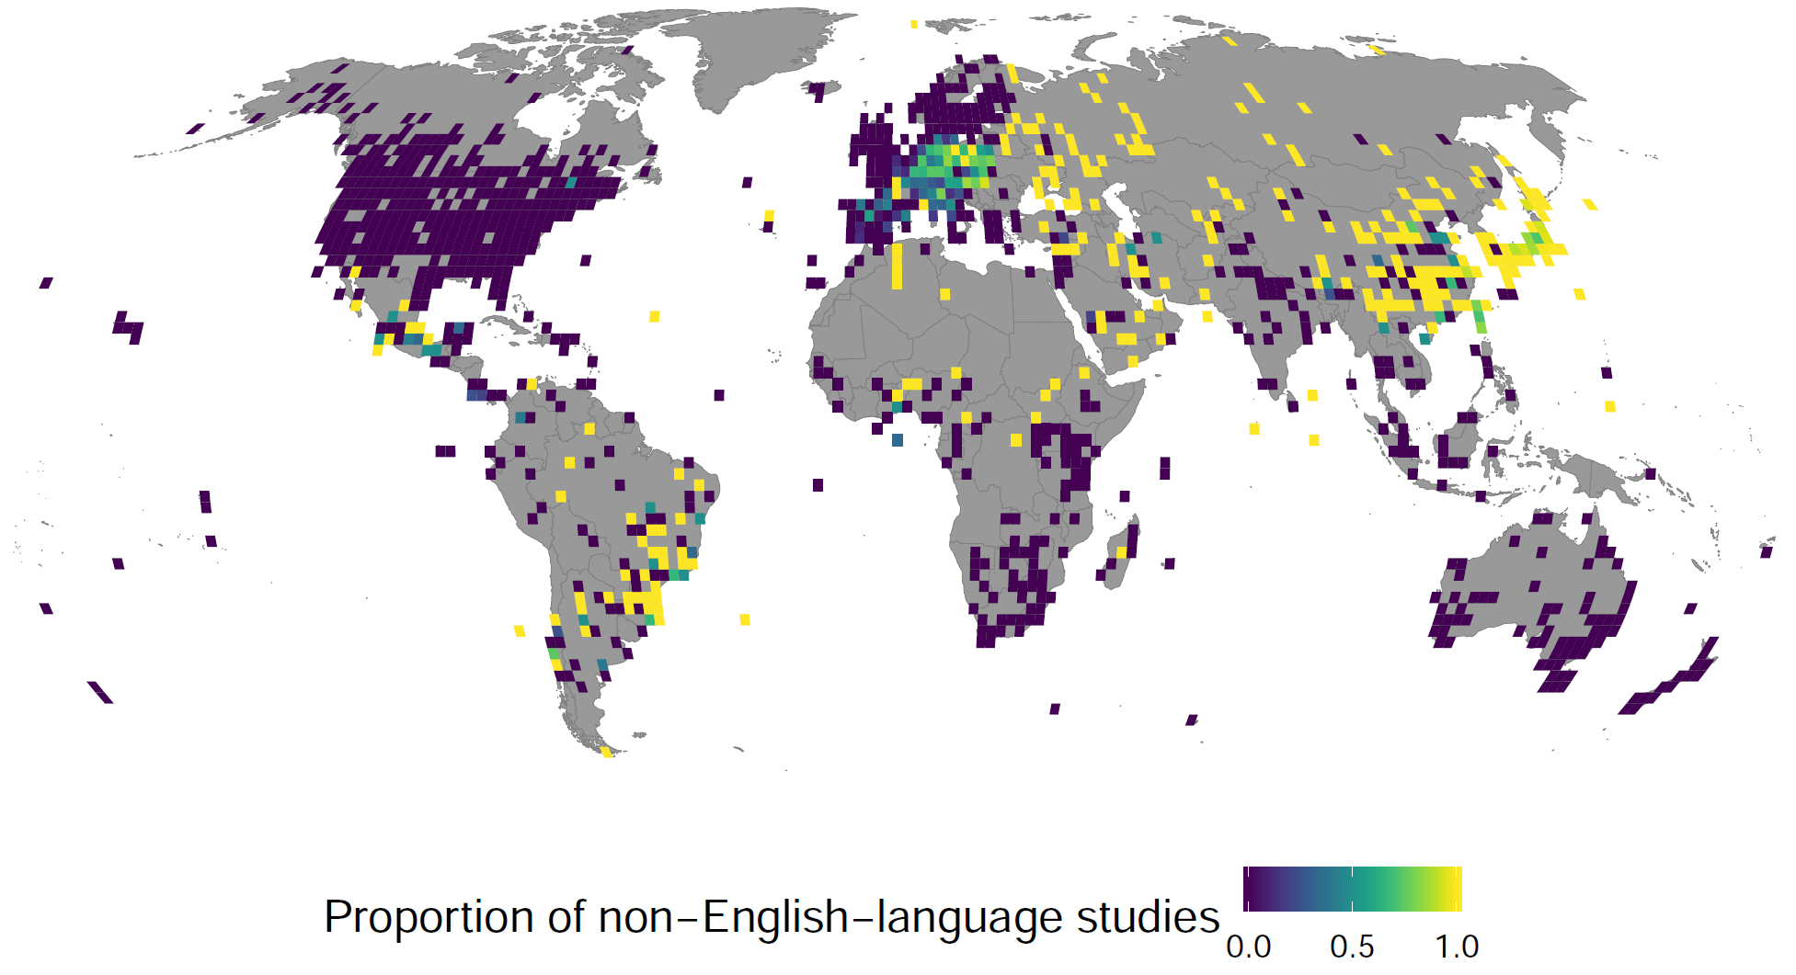

**S2 Fig.** The proportion of non-English-language studies (all 16 languages combined) to all studies (i.e., non-English and English-language studies combined) testing the effectiveness of conservation interventions within each 2° × 2° grid cell. This figure was created using S3 and S4 Data with Code 3. Map produced from the Natural Earth dataset (v.4.1.0) at 1:50m scale (https://www.naturalearthdata.com/downloads/50m-cultural-vectors/).