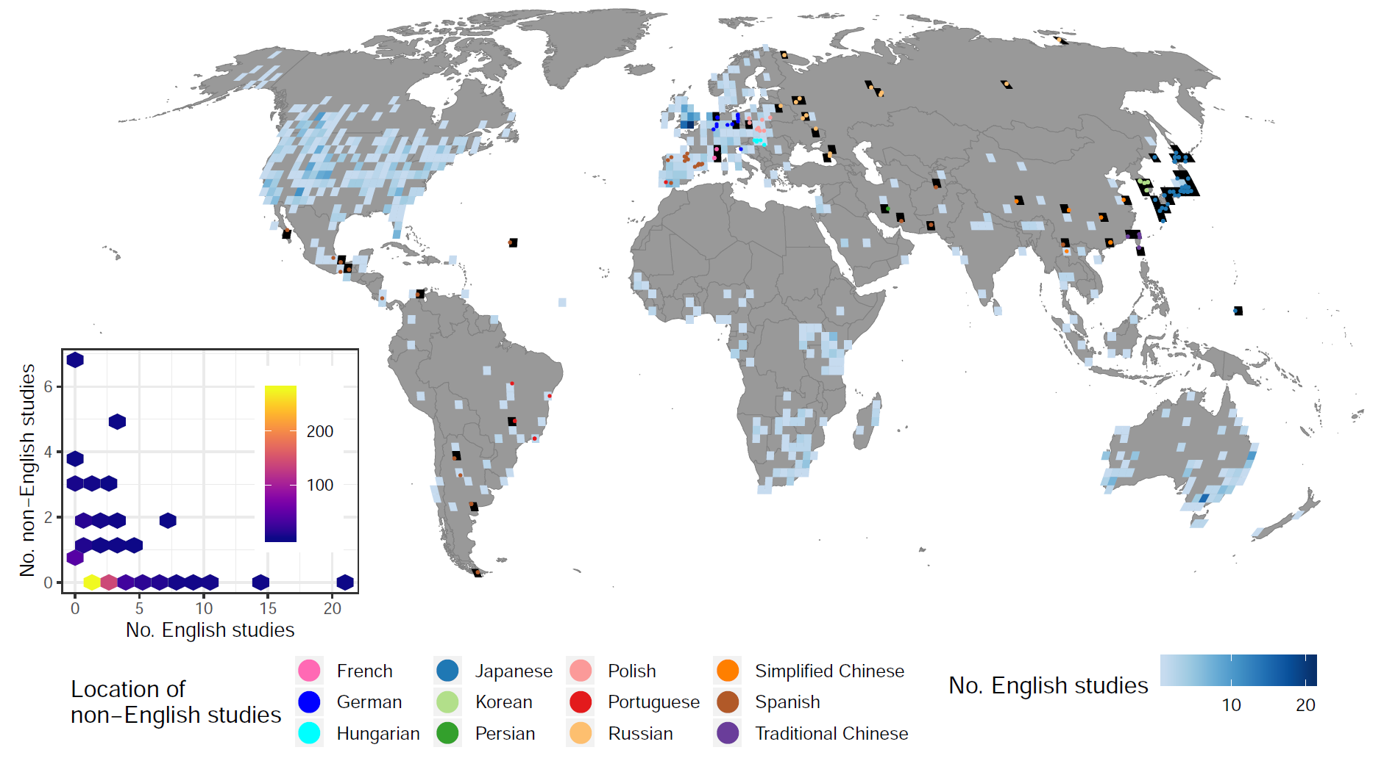

**S5 Fig.** The location of 146 non-English-language studies testing the effectiveness of conservation interventions for mammal species (published in 2018 or earlier), compared to the number of English-language studies on mammals within each 2° × 2° grid cell (514 grid cells in total). Non-English-language studies were found in 89 grid cells, 61 of which were without any English language studies (grid cells in black). The inset is a hexbin chart showing a significantly negative relationship between the number of English-language studies (No. English studies) and the number of non-English-language studies (No. non-English studies) within each grid cell. Brighter colours indicate more grid cells in each hexagon. This figure was created using S3 and S4 Data with Code 6. Map produced from the Natural Earth dataset (v.4.1.0) at 1:50m scale (https://www.naturalearthdata.com/downloads/50m-cultural-vectors/).